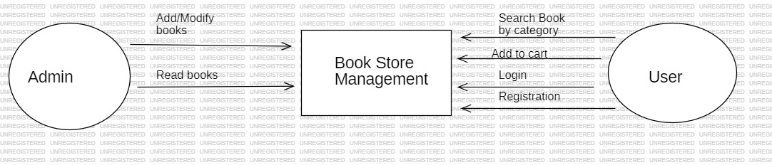

**ZEROTH LEVEL DATA FLOW DIAGRAM**

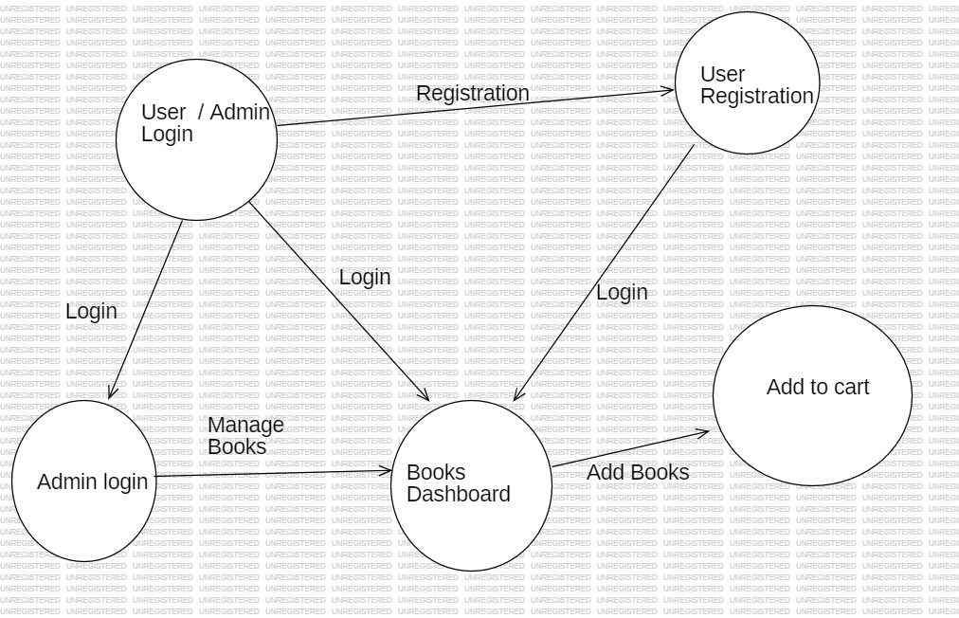

**FIRST LEVEL DATA FLOW DIAGRAM**

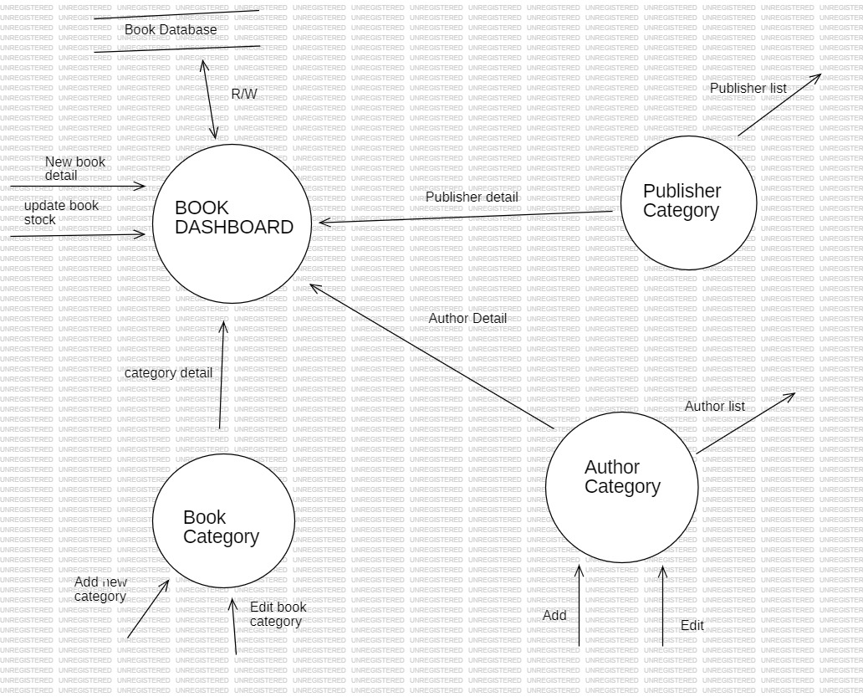

**SECOND LEVEL DATA FLOW DIAGRAM**